# **CTF Challenge: Scanning IP Address - Using AbuseIPDB**

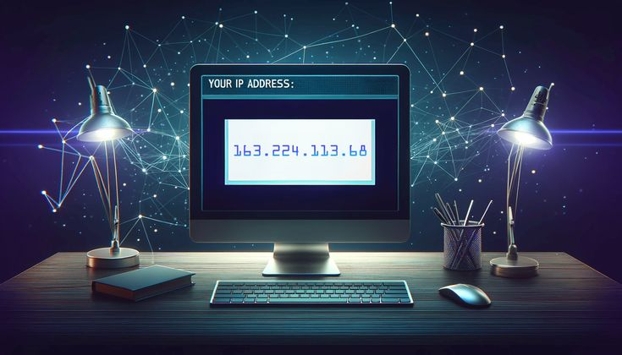

# **1. Introduction**

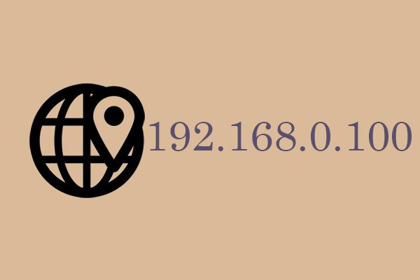

AbuseIPDB allows users to report and check IP addresses for abusive activities. This challenge will introduce you to using AbuseIPDB to gather information about a specific IP address.

# **2. Tools and Requirements**

Access to the internet and search for AbuseIPDB

# **3. Scenario**

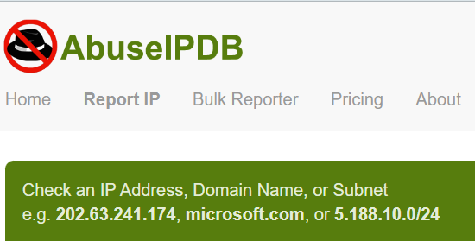

You are an ethical hacker tasked with gathering information about a specific IP address using AbuseIPDB. Your job is to determine if the IP address has been reported for abusive activities and identify one relevant detail associated with it.

# **4.Process to follow while performing CTF**

Step 1: Go to your browser and Visit AbuseIPDB: [**https://www.abuseipdb.com/**](https://www.abuseipdb.com/)

Step 2: IP Address Lookup: Enter the IP address **202.63.241.174** in the search bar and start the lookup.

Step 3: Solve the CTF.

# **5. Let’s Begin the Challenge**

**Question**

**Flag 1: What is the ISP of a given IP address?**

Answer: Subisu Corporate Pool

**Flag 2: What is the usage type of provided IP address?**

Answer: Fixed Line ISP

**Flag 3: What is the percentage of Confidence of Abuse of the IP Address?**

Answer: 0%

**Flag 4: In which country the IP Address is located?**

Answer: Nepal

**Hint**

Use the "IP Address Lookup" tool on AbuseIPDB to perform the analysis.

